DIFFERENTIAL RESPONSES ON SEED GERMINATION AND GROWTH OF THREE THAI RICE CULTIVARS TO REACTIVE NITROGEN SPECIES

KamonpornPanngom^{1*}, ThanyaratChuesaard¹, MukdawanPakdiyong²,Kantima Thananurat²
^{1*}Basic Science Program,Maejo University Phrae Campus, Rongkwang, Phrae, 54140, Thailand,
E-mail; kamonpornp@gmail.com,kamonporn@phrae.mju.ac.th
¹Basic Science Program,Maejo University Phrae Campus, Rongkwang, Phrae, 54140, Thailand,
E-mail;Thanyarat@phrae.mju.ac.th
²Plant Production Technology Program, Maejo University Phrae Campus, Rongkwang, Phrae, 54140, Thailand,
E-mail; copy-vintage@hotmail.com; ntaan.gg@gmail.com

Paper belongs the below themes (tick on the theme number):
1. | 2. | 3. | 4.
5. | 6. | 7.

Abstract
Reactive oxygen and nitrogen species (RONS) play an important role for signaling molecule of redox reaction in various biological pathways in living organisms. The role of reactive nitrogen species is reported in several functions in plants. Enhancement of the early seed germination stage by using reactive species molecules has shown in several previous studied and also it can be effected to increasing of plant yield. Rice is an important economical and the main food crop for agriculturist in Thailand. Low rate and inconsistency of seed germination rate can directly reduce rice yields. Therefore, the goalof this research is to evaluate the influence of nitric oxide generated from sodium nitroprusside (SNP) to enhance seed germination and growth of three Thai rice cultivars including; KhaoDowk Mali 105, Sanpatong and Pitsanulok 2. The results showed that the NOtreatment showed increasing ofthe percentage of seed germination rate in three Thai rice cultivars especially 25µM of SNP for 24 hrs on KhaoDowk Mali 105.Among three Thai rice cultivars, KhaoDowk Mali 105 showed greater responses to nitric oxide than Pitsanulok 2 and Sanpatong. The percentage of seed germination rate of Sanpatong was reduced when the NO concentration and treatment time increased. In addition, the growth rate (height, wet and dry weight) of 15 days old of seedling plants wasincreased after NO treatment for 12 hrs treatment but not much difference in 24 hrs treatment. To analyzean important mechanism of NO for enhancing seed germination and plant growth requires additional studies.

Keywords: Nitric oxide, Nitrogen reactive species, Rice, Seed germination, Growth

Introduction
Reactive nitrogen species (RNS) play an important role for redox signaling in a biological system of organisms such as cell growth and elongation, cell death and cell immunity [1-2]. Dynamic actions of RNS are depending on an amount and concentration [1,3].In plants, reactive species can be expressed for induction of root elongation, leaf expansion, plants growth and immune activation, and seed and pollen germination [2-5]. Seed germination is the first stage of plant life cycle begin and this process has been various factors for controlling of seed germination such asphytohormones, moisture, chemical substances, andvarious abiotic factors [5-8]. In addition, seed germination process is an important indicator for determination of plant yield for agricultural plant system [9]. Several economic crops havea serious problem in seed germination stage because seeds have been a long term of dormancy after fruit or pod ripening [10]. Additionally, some plants seeds need a specific factor for seed germination step and also seed germination rate is an inconsistency which is effect from fluorescence behavior [10]. Therefore, farmers try to find out a method for activation or enhancingthe rate of seed germination by using severalways such as seed treatmentwith plant hormones, heat, basic and acidic chemicals, and cutting and timingof theirseed coat [5-8].
Recently, treatment of plant seeds with reactive oxygen and nitrogen species (RONS) generated from the chemical donors can be enhancedon early and consistency of seed germination rate in several previous reported [4-7,11-13]. Thai rice is an economic plant for Thailand because they are a main and famous crop to export in worldwide. Generally, rice seed has been adormancy perioddiffer among varieties and inconsistency of germination rate depending on seed olds.Also, seed quality and seed vigor are the main factors for determination ofplant yield production. To increase of plant yield and to decrease of products cost need to carry out for an agricultural system.RNS generated from chemical donor may have a potential role to use for an activation of seed germination and also it should be a good way for help farmers to reduce the cost for plant productivity.
Herein, this research evaluated the role of reactive nitrogen species (RNS) which is generating from chemical donor to an activation of seed germination and growth of three Thai rice cultivars. In addition, we also provided the data of differential responses onseed germination and growth of three Thai rice cultivars to nitric oxide generated from SNP chemical donor.

Materials and Methods
In this experiment, we used seeds of three Thai rice cultivars including; KhaoDowk Mali 105, Sanpatong and Pitsanulok 2 which is kindlygivenfrom Rice Seed Center, Phrae Province, Thailand. Rice seeds were treatment with nitric oxide (NO) generated from sodium nitroprusside (SNP)(Sigma-Aldrich, St. Louis, MO) in the water. Fifty seeds of rice were treated in sodium nitroprussidesolution in several concentrations; 12.5, 25, 50 and 100 µM for 12 and 24 hrs. Then, rice seeds were put on two layers of wet cultivate paper in a petri dish (⌀90 cm.). Seed germination was counted for 12, 24, 36, 48, 72 and 96 hrs and then the percentage of seed germination rate was calculated to follow this formula; the number of seed germination/number of total seeds x 100. For the growth of the seedling plant, we grew seedling rice for 15 days, then we harvested seedling plants and measured the plant length and wet weight. Then, we dried seedling plants by using hot air ovenat 60 °C for 2 days and then the dry weight was measurement. All experiments were done for three times and three replicates in each treatment. Data analysis of percentage of seed germination, plant length, wet and dry weight were calculated mean ± standard deviation (SD) and statistical analysis were used student’s t-test for carried out a significance between data points (denote *p≤0.05, **p≤0.01)

Results and Discussion
Reactive nitrogen species enhanced differentially on seed germination of three Thai rice cultivars
To evaluatethe role of RNSon seed germination process of Thai rice cultivars,seeds of three Thai rice were treated with NO generated from SNP in several concentrations; 12.5, 25, 50, and 100 µM in water for 12 and 24 hrs. The results showed that at 12 and 24 hrs treatment time, the percentage of seed germination rate was increased significantly especially KhaoDok Mali 105 and Pitsanulok 2 after NO chemical donor treatment when comparing with control experiment. It should be noted that seed germination rate showed highly increased after treatment with 12.5 and 25 µM of SNP for12 and 24 hrs. Among three Thai rice cultivars, we found that KhaoDok Mali 105 showed greater responses to NOchemical donor than Pitsanulok 2 and Sanpatong, respectively. In addition, the percentage of seed germination rate of Sanpatong cultivar was reduced when the NO concentration and treatment time increasing [Figure 1].At 12 and 24 hrsgermination timesof 24 hrstreatment time on KhaoDowk Mali 105seeds werehighlyspeedgermination rate after treated with nitric oxide donor than other cultivars.
Our data confirm that RNS can be used for enhancement on seed germinationin rice which is founded in several plants in previous research such as wheat, rice,and cucumber [5,6,13].In general, NOnot only plays an important role for signaling pathway for plant immune system but also uses for breaking of seed
dormancy and enhancing of seed germination in plants [5,15].
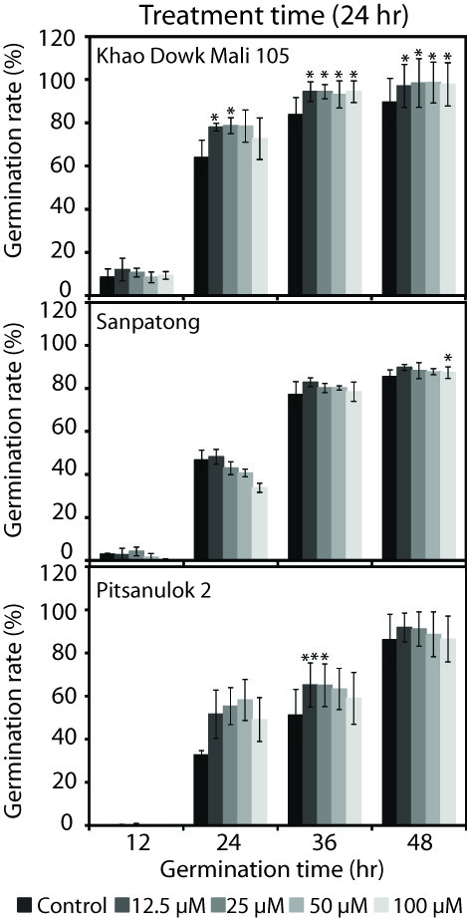
Figure 1. The percentage of seed germination rate of three Thai rice cultivars; KhaoDowk Mali 105, Sanpatong and Pitsanulok 2after SNP treatment for 24 hrs. The percentage of seed germination rate was highly increased in KhaoDowk Mali 105, Pitsanulok 2 and Sanpatong, respectively. (Student’s t-test was used for statistical analysis. denote *p≤0.05, **p≤0.01)

Among Thai rice cultivars showed differential responses to NO, it may cause from difference of rice cultivar which has a diversity among cultivars characters. It is noted that reactive RONS may trigger with seed germination and dormancy-related hormones in both of gibberellic acid (GA) and abscisic acid (ABA) for regulation of seed metabolisms in plants [7]. Moreover,reactive species are positive enhancement on plants totolerate an abiotic stress
such as salt and drought stress [13]. The role of RNS in plants for growth and development activation in plants should be elucidated.

Reactive nitrogen species enhanced differentially on seedling growth of three Thai rice cultivars
To examine the effect of NOgenerated from SNP on plant growth and development, we measured the plant length of rice seedling which has aged for 15 days old. The length of plant seedling of two Thai rice cultivars including Sanpatong and Pitsanulok 2 were notmuch different among SNP concentrations treatment
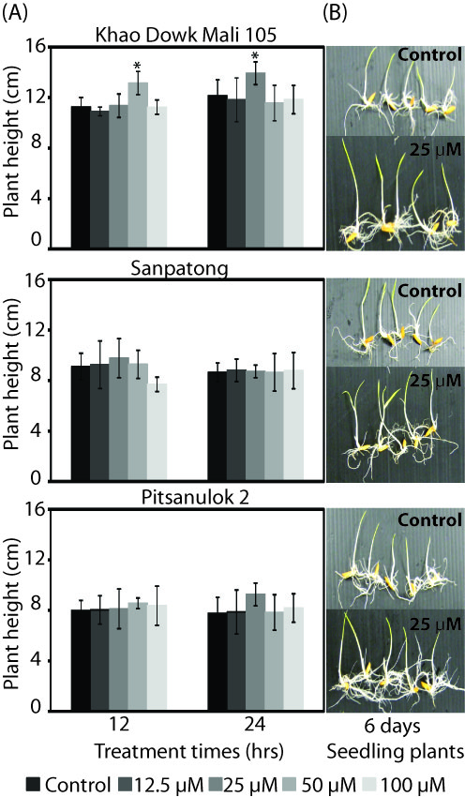
Figure 2. The seedling morphology(6 days old) and seedling length (15 days old) of three Thai rice cultivars; KhaoDowk Mali 105, Sanpatong and Pitsanulok 2 after treatment with SNP for 12 and 24 hrs. The seedling length was increased after SNP treatment for 12 and 24 hrs. (Student’s t-test was used for statistical analysis. denote *p≤0.05, **p≤0.01)
when comparing with control experiment. In the other hand, KhaoDowk Mali 105 showed significant increasingof the plant length after treatment with SNP concentration of 50 µM for 12 hrs and 25 µM for 24 hrs [Figure 2A]. In addition,rice seedling morphology of three Thai rice cultivars after germination for 6 days displayed the plant length was longer than control experiment especially KhaoDowk Mali 105 [Figure 2B]. For wet and dry weight of three Thai rice cultivars, the resultsshowed that the wet and dry weight increased among three Thai rice cultivars especially KhaoDowk Mali 105 whichsignificantly increased after SNP treatment for 12 and 24 hrs but not much significantly inSanpatong and Pitsanulok 2cultivars [Figure 3A and 3B].
In case of growth and developmentof rice seedling expressed increasing of the plant length that means reactive species not only enhancement of speed germination of plant seeds but also induced growth and development in plants. Several previous reported mentions that RNS can activate various biological processes in plants such as growth and development, program cell death, chlorophyll synthesis, seed germination and plant defense system [3,4,15].

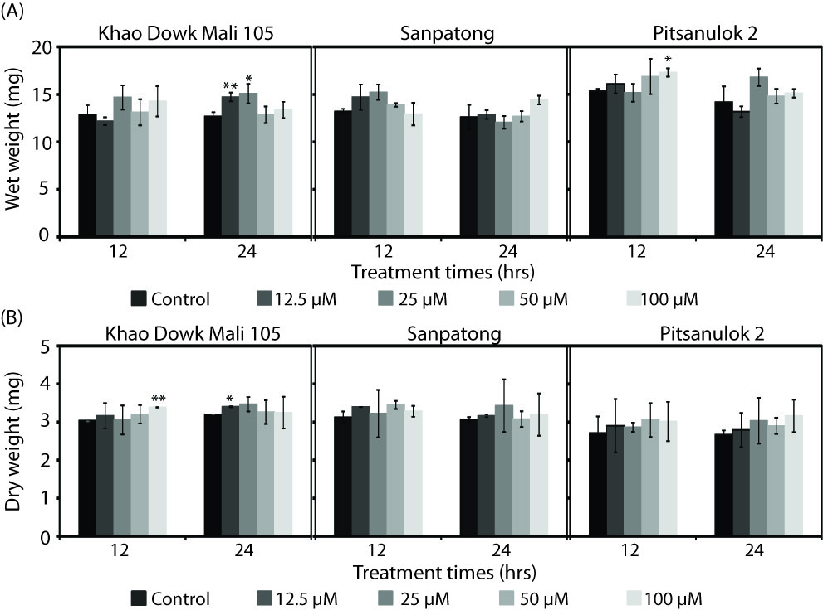
Figure 3. Thewet and dry weightofseedling plants (15 days old) of three Thai rice cultivars; KhaoDowk Mali 105, Sanpatong and Pitsanulok 2 after treatment with several concentrations of SNP including 12.5, 25, 50 and 100 µMfor 12 and 24 hrs. The wet and dry weight of KhaoDowk Mali 105 significantly increased after 12.5 and 25 µM of SNP treatment seeds for 24 hrs. (Student’s t-test was used for statistical analysis. denote *p≤0.05, **p≤0.01)

Conclusions
In conclusion, seed germination rate of three Thai rice cultivars was increased after NO treatment in both of 12 and 24 hrs.The concentration of NO at 25 µM of SNP treatment for 24 hrson KhaoDowk Mali 105 was showed highly significant increasing. Among three Thai rice cultivars, KhaoDowk Mali 105 showed the best responses to NO than Pitsanulok 2 and Sanpatong. The percentage of seed germination rate of Sanpathong was reduced when the NO concentration and treatment time increasing. In addition, the growth rate (height, wet and dry weight) of 15 days olds of seedling plants increased after NO treatment for 12 hrs treatment but not significant difference in 24 hrs treatment.

Acknowledgements
This work was supported by the grants project entitle role of hydrogen peroxide and nitric oxide for enhancing of seed germination and growth of rice, Maejo University Phrae Campus in the year of 2015 (MJ.2-58-005). Also, we would like to thanks, Rice Seed Center, Phrae Province, Thailand to kindly given rice seeds for the experiment.

References
[1] Graves D.B. 2012. The emerging role of reactive
oxygen and nitrogen species in redox biology and some implications for plasma applications to medicine and biology. Apply Physics. 45: 1-36.
[2] Halliwell B. 2006. Reactive species and antioxidants:
Redox biology is a fundamental theme of aerobic life. Plant Physiology, 141: 312–322
[3] Mur A.J.L., Mandon J., Persijn S., Cristescu M.S..,
Moshkov E.I., Novikora V.G.,et.al. 2012. Nitric oxide in plants: an assessment of the current state of knowledge. AoB Plants. 5:1-17.
[4] del Rio L.A., Corpas J.F., Barroso B.J. 2004. Nitric
oxide and nitric oxide synthase activity in plants. Phytochemistry. 65: 783-792.
[5] Desikan R., Cheung M.K., Bright J., Henson D.,
Hancock J.T., et al. 2004. ABA, hydrogen peroxide and nitric oxide signaling in stomatal guard cells. Journal of Experimental Botany. 55(395): 205-212.
[6]Sirova J., Sedlarova M., Piterkova J., Luhova L.,
Petrivalsky M., 2011. The role of nitric oxide in the germination of plant seeds and pollen. Plant Science. 181: 560-572.
[7] Zheng C., Jiang D., Liu F., Dai T., Liu W., Jing Q., Cao W. 2009. Exogenous nitric oxide improvesseed germination in wheat against mitochondrial oxidative damage induced by high salinity. Environmental and Experimental Botany. 67: 222–227.
[8] Liu Y., Ye N., Liu R., Chen M., Zhang J. 2010.
H₂O₂ mediates the regulation of ABA catabolism and GA biosynthesis in Arabidopsis seed dormancy and germination. Journal of Experimental Botany. 61(11): 2979-2990.
[9] Trugo L. C., Donangelo C. M., N. Trugo M. F.,
Bach Knudsen K. E. 2000. Effect of heat treatment on nutritional quality of germinated legume seeds. Journal Agricultural Food Chemistry. 48: 2082−2086.
[10]Nonogaki H. 2016. Seed germination-The biochemicaland molecular mechanisms. Breeding Science. 56: 93-105.
[11] Bewley J. D. 1997. Seed germination and dormancy.
The Plant Cell. 9: 1055-1066.
[12] Kopyra M., Gwóz´dz E.A. 2003. Nitric oxide stimulates
Seed germination and counteracts the inhibitory effect of heavy metals and salinity on root growth of Lupinusluteus. Plant Physiology and Biochemistry: 41: 1011–1017.
[13] Çavusoglu K., Kabar K. 2010. Effects of hydrogen peroxide on the germination and early seedling growth of barley under NaCl and high temperature stresses. EurAsia Journal of Bioscience. 4: 70-79.
[14] Liu H.Y., Yu X., Cui D.Y., Sun M.H., Sun W.N., et al. 2007. The role of water channel proteins and nitric oxide signaling in rice seed germination. Cell Research. 17:638-649.
[15] Arc E., Galland M., Godin B., Cueff G., Rajjou L. 2013. Nitric oxide implication in the control of seed dormancy and germination. Frontiers in Plant Science. 4: 1-13.

